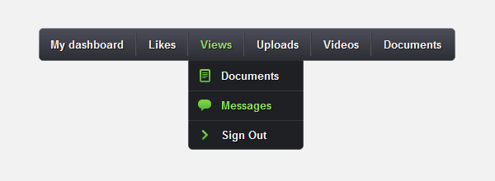

TO CREATE A Dropdown Menu CSS3

Step 1. HTML

We will create a list ul card.
1  2  3  4  5  6  7  8  9  10  11  12  13  14  15  16  17  18 | <ul class="menu">  <li><a href="#">My dashboard</a></li>  <li><a href="#">Likes</a></li>  <li><a href="#">Views</a>  <ul>  <li><a href="#" class="documents">Documents</a></li>  <li><a href="#" class="messages">Messages</a></li>  <li><a href="#" class="signout">Sign Out</a></li>  </ul>  </li>  <li><a href="#">Uploads</a></li>  <li><a href="#">Videos</a></li>  <li><a href="#">Documents</a></li>  </ul>

Results


Step 2. CSS on menu

Show the link in a row, the background color for the menu.
1  2  3  4  5  6  7  8  9  10  11  12  13  14  15  16  17  18  19  20  21  22  23  24  25  26  27  28  29  30  31  32  33 | .menu,  .menu ul,  .menu li,  .menu a {  margin: 0;  padding: 0;  border: none;  outline: none;  }  .menu {  height: 40px;  width: 505px;  background: #4c4e5a;  background: -webkit-linear-gradient(top, #4c4e5a 0%,#2c2d33 100%);  background: -moz-linear-gradient(top, #4c4e5a 0%,#2c2d33 100%);  background: -o-linear-gradient(top, #4c4e5a 0%,#2c2d33 100%);  background: -ms-linear-gradient(top, #4c4e5a 0%,#2c2d33 100%);  background: linear-gradient(top, #4c4e5a 0%,#2c2d33 100%);  -webkit-border-radius: 5px;  -moz-border-radius: 5px;  border-radius: 5px;  }  .menu li {  position: relative;  list-style: none;  float: left;  display: block;  height: 40px;  }

Hide links subordinates 2.
1 | .menu ul { display: none; }

Results:
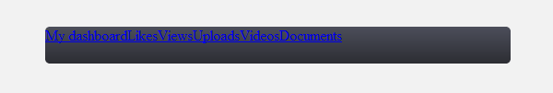

Step 3. CSS for the links.

1  2  3  4  5  6  7  8  9  10  11  12  13  14  15  16  17  18  19  20  21  22  23  24  25  26  27  28 | .menu li a {  display: block;  padding: 0 14px;  margin: 6px 0;  line-height: 28px;  text-decoration: none;  border-left: 1px solid #393942;  border-right: 1px solid #4f5058;  font-family: Helvetica, Arial, sans-serif;  font-weight: bold;  font-size: 13px;  color: #f3f3f3;  text-shadow: 1px 1px 1px rgba(0,0,0,.6);  -webkit-transition: color .2s ease-in-out;  -moz-transition: color .2s ease-in-out;  -o-transition: color .2s ease-in-out;  -ms-transition: color .2s ease-in-out;  transition: color .2s ease-in-out;  }  .menu li:first-child a { border-left: none; }  .menu li:last-child a{ border-right: none; }  .menu li:hover > a { color: #8fde62; }
Results:


Step 4. Submenu

First, remove the hidden lines of level 2 link above.
1 | .menu ul { display: none; }
Instead of using this code:
1  2  3  4  5  6  7  8  9  10  11  12  13  14  15  16  17  18  19  20  21  22  23  24  25  26  27  28  29  30  31  32  33  34  35  36  37  38 | .menu ul {  position: absolute;  top: 40px;  left: 0;  opacity: 0;  background: #1f2024;  -webkit-border-radius: 0 0 5px 5px;  -moz-border-radius: 0 0 5px 5px;  border-radius: 0 0 5px 5px;  -webkit-transition: opacity .25s ease .1s;  -moz-transition: opacity .25s ease .1s;  -o-transition: opacity .25s ease .1s;  -ms-transition: opacity .25s ease .1s;  transition: opacity .25s ease .1s;  }  .menu li:hover > ul { opacity: 1; }  .menu ul li {  height: 0;  overflow: hidden;  padding: 0;  -webkit-transition: height .25s ease .1s;  -moz-transition: height .25s ease .1s;  -o-transition: height .25s ease .1s;  -ms-transition: height .25s ease .1s;  transition: height .25s ease .1s;  }  .menu li:hover > ul li {  height: 36px;  overflow: visible;  padding: 0;  }

Then we'll put the link width is 100px, along with some other things.
1  2  3  4  5  6  7  8  9  10 | .menu ul li a {  width: 100px;  padding: 4px 0 4px 40px;  margin: 0;  border: none;  border-bottom: 1px solid #353539;  }  .menu ul li:last-child a { border: none; }

You can also put some background as to the link icon in the level 2.
1  2  3 | .menu a.documents { background: url(../img/docs.png) no-repeat 6px center; }  .menu a.messages { background: url(../img/bubble.png) no-repeat 6px center; }  .menu a.signout { background: url(../img/arrow.png) no-repeat 6px center; }

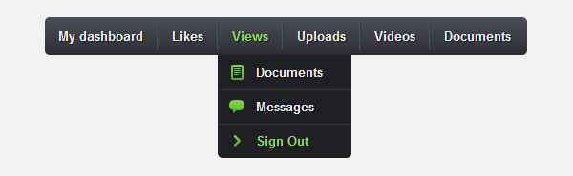
Results:
I wish you success.

